Campus Companion — Report
CA3 Component 1 | Team: Arben, Vlad, Joel, Zehad and Galo

1. Project Overview and Problem Statement
Campus Companion is a student-facing web application built to help first-year college students navigate campus life. Starting college creates an immediate information problem: students need to find events, locate buildings, solve issues, and manage their timetable, yet this information is typically provided across notice boards, emails, and institutional portals that are rarely mobile-first.
The application provides five core features: a home dashboard with quick links and an events preview, an events page with category filtering, a campus locations directory, a helpdesk form for submitting support requests, and an accessibility settings page with text-size scaling, high-contrast mode, and reduced-motion control. Optional features added where time allowed include a timetable viewer, a societies list, account and login functionality, and a machine-learning event recommender. All data is fictional and created specifically for this project.
The technical stack is Next.js 15 with the App Router, TypeScript, Tailwind CSS v4, and Supabase for authentication and PostgreSQL storage, deployed to Netlify.

2. Target Users and User Needs
The primary audience is first-year students. Secondary audiences are staff and administrators.
First-Year Student (Aoife, 18): Aoife needs to find events, locate buildings, and submit a helpdesk ticket. She is unfamiliar with campus, unsure who to contact for IT problems, and uses her phone primarily. She occasionally prefers larger text in busy environments.
Teaching Staff (Dr Kavanagh, 42): Kavanagh wants to view his timetable and check room allocations. Timetable changes are communicated late and there is no single place to check his schedule.
Student with Accessibility Needs (Dara, 20): Dara uses keyboard-only navigation and a screen reader. She needs high contrast, enlarged text, reduced motion, and full keyboard support.
These personas shaped decisions around navigation simplicity, mobile-first layout, WCAG compliance, and the inclusion of the Accessibility Settings page.

3. System Design: Inputs, Processes, Outputs (IPO)
Input | Process | Output
User selects event category filter | Client-side filter applied to loaded events array | Filtered event cards displayed
User submits helpdesk form | Client-side validation; POST to Supabase helpdesk_tickets | Success confirmation shown; ticket stored
User logs in | Supabase Auth validates credentials; session stored | User redirected; role-specific content visible
User changes text size or contrast | AccessibilityProvider writes data attributes to HTML element | All text and colours update globally
ML recommender reads user categories | Cosine similarity calculated against event tag vectors | Ranked recommendations shown on home page
The system follows a client-heavy architecture. Data is fetched from Supabase on page load and filtered on the client, reducing server round-trips and enabling fast interaction within the static export deployment model.

4. Architecture Overview
Campus Companion uses a JAMstack architecture: a statically exported Next.js frontend hosted on Netlify, connected to Supabase for authentication and database functionality.
The client is Next.js 15 with the App Router and React 19. All pages are rendered as static HTML at build time with no Node.js server at runtime. Data requiring authentication is fetched on the client after the Supabase session is established. The project is structured into app pages, shared components, a Supabase client library, and TypeScript type definitions.
Supabase provides hosted PostgreSQL with row-level security enabled on all tables. A student can only read their own profile and cannot modify other users' data. The anon key handles unauthenticated reads of public data; the authenticated session key is required for profile and timetable access. When a user signs up, a database trigger automatically creates a profiles row with a default role of student. Role-based access covering student, teacher, and admin controls which UI sections are displayed.
Netlify connects to the GitHub repository and every push to main triggers a build. Environment variables for the Supabase URL and anon key are stored in Netlify project settings and injected at build time.

5. Data Design (Conceptual)
The data model centres on the user profile and its relationships to campus content. The profiles entity stores identity, role, year of study, and society preferences, with one profile per authenticated user. Events have many tags used by the ML recommender. Locations are standalone. Timetables are filtered by student year or teacher. Helpdesk tickets belong to a profile and store category, urgency, and description. Announcements are optionally role-gated and shown on the home dashboard.
In line with GDPR data minimisation, the application deliberately avoids collecting data not required for its purpose. The following is not collected: GPS or location data from the device, browsing history or click-tracking analytics, device identifiers, real student numbers, medical or financial data, and third-party social login tokens. All personal data collected is the minimum necessary to provide core features, and all dataset content used during development is entirely fictional.

6. Usability and UI Design Decisions
The application uses a persistent navigation bar on every page with descriptive text labels. A skip-to-content link is the first focusable element, allowing keyboard users to jump past the navigation directly to the main content area.
All pages share the same layout wrapper, ensuring consistent spacing, typography, and colour. Event and location cards follow a uniform card pattern with heading, description, and metadata. Primary actions use the brand blue; secondary actions use an outlined style. Form elements are consistently sized across Helpdesk and Account pages.
User initiated actions produce visible feedback. The helpdesk form shows a success confirmation after submission. Auth errors appear immediately. The Settings page confirms each change without moving focus. All grids and flex containers are single column at narrow widths and expand at larger breakpoints, tested at 320 px viewport width with no horizontal scroll.

7. Accessibility Plan (WCAG-Aligned Decisions)
The accessibility strategy targets WCAG 2.2 Levels A and AA. A full audit was carried out on the feature/accessibility branch by Zehad Zaman on 30 April 2026, covering all pages.
All pages use semantic HTML5 landmark elements. Each page has one h1 followed by h2 subheadings. Every form input has an explicit label. The settings page groups controls into fieldset elements with legend, and each group references a hint paragraph via aria-describedby.
All interactive elements are native HTML with no div or span click handlers. Tab order follows DOM order throughout. A global focus-visible CSS rule provides a 3 px solid blue outline at 5.9:1 contrast, exceeding the 3:1 minimum required by WCAG 2.4.11.
Primary body text exceeds 7:1 contrast. One known issue remains where slate-500 text achieves approximately 4.0:1, below the 4.5:1 AA threshold. This is mitigated by high-contrast mode which switches the application to black background and white text, achieving 21:1. The settings page offers Normal, Large, and Extra Large text sizes by scaling the HTML element font-size, proportionally adjusting all rem-based utilities.
All asynchronous status messages use ARIA live regions. Helpdesk success uses role of status with polite behaviour. Auth errors use role of alert with assertive behaviour. Before these changes, screen readers received no announcement on form submission or error.

8. Privacy, Security, and Compliance
Account registration relies on contract as the lawful basis: users provide credentials specifically to access account features. Helpdesk submissions are processed based on legitimate interests in providing student support. No data is processed for marketing or analytics, and no consent banners are required because no tracking technologies are used.
Unauthorised database access is mitigated by Supabase row-level security. API credentials are stored in environment variables and never in version control. Injection attacks are mitigated by Supabase's parameterised queries. Role escalation is restricted to direct SQL by an admin. Sessions use short-lived JWTs with automatic refresh. All production traffic is served over HTTPS enforced by Netlify.

9. Deployment Plan (Conceptual)
The application deploys to Netlify via continuous deployment connected to GitHub. Every push to main triggers npm run build, generating a static export in the out directory as specified in netlify.toml.
Two environment variables are required: the Supabase project URL and anon key, stored in .env.local locally and in Netlify project settings for production. The database is initialised by running the schema SQL file in the Supabase SQL editor, which creates all tables, enables row-level security, defines triggers, and seeds fictional starter data.
To reproduce the deployment: create a Supabase project and run the schema SQL, add the keys to Netlify environment variables, connect the GitHub repository, trigger an initial deploy, and set the Supabase Auth site URL to the Netlify domain. A move to server-rendered deployment would require a Node.js-capable host and is noted as a future consideration.

10. Appendix
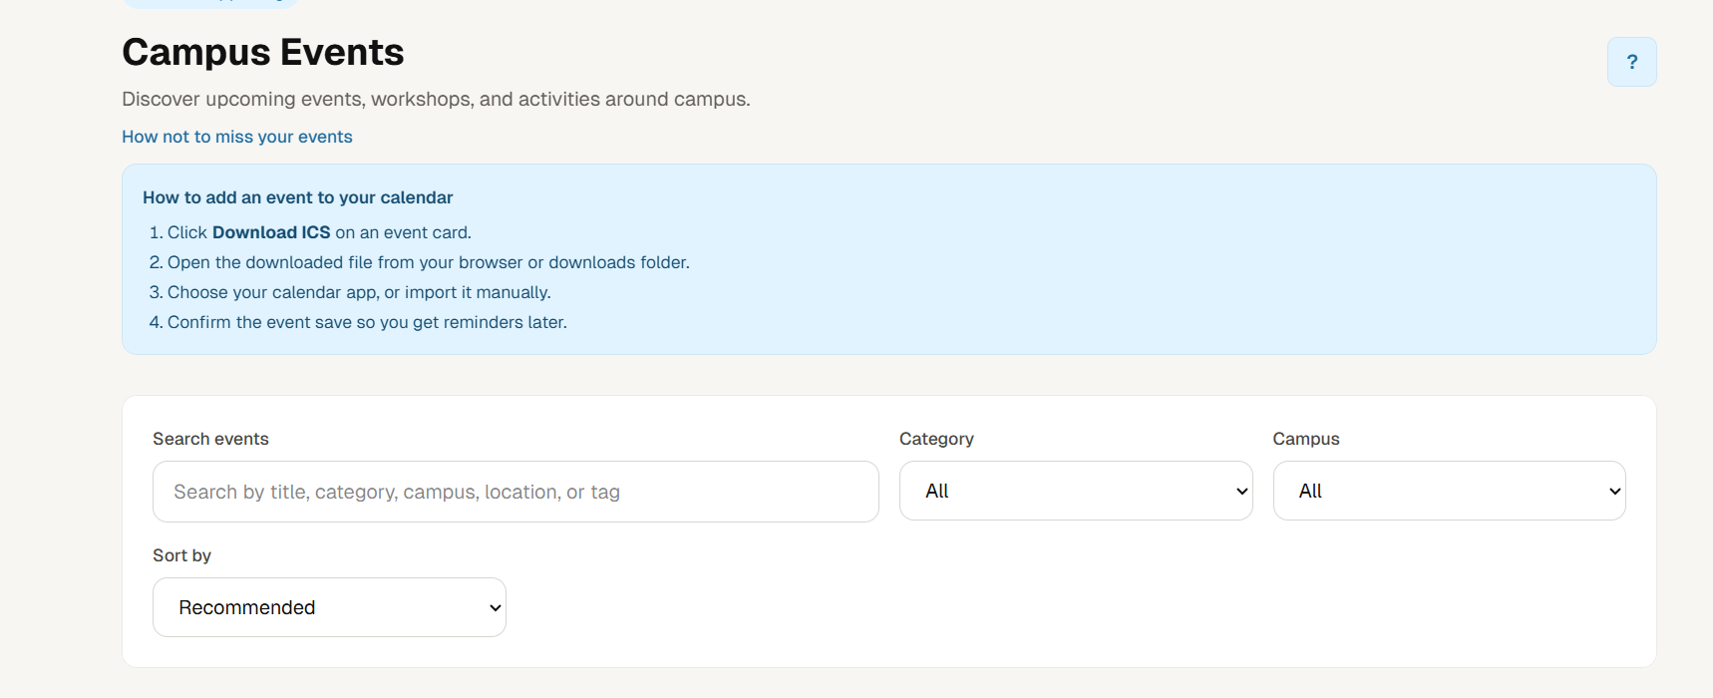
The top of the events page showing the page heading, a collapsible info box explaining how to add events to a calendar using the ICS download.

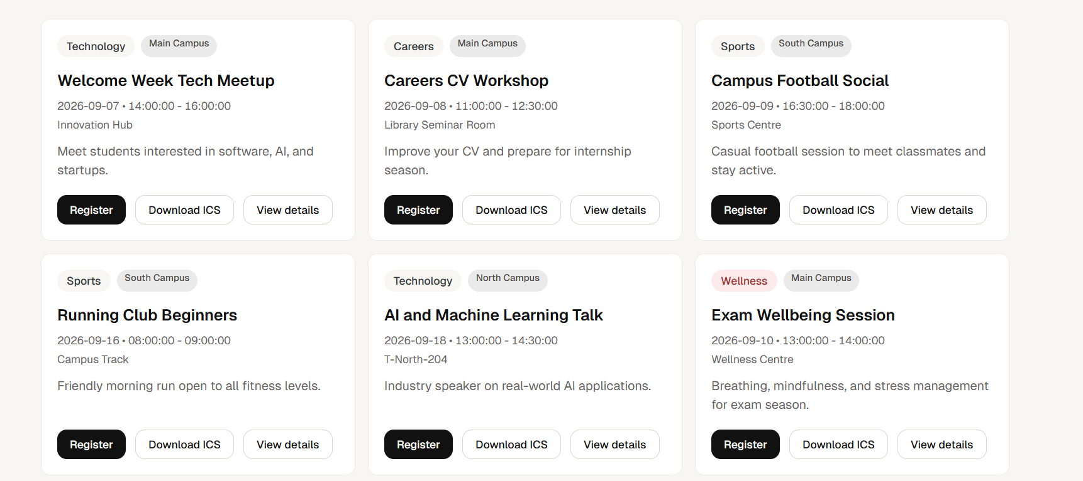
A grid of event cards each showing the event title, category tag, campus location, date and time and a short description. Events shown cover a range of categories including Technology, Careers, Sports, and Wellness.
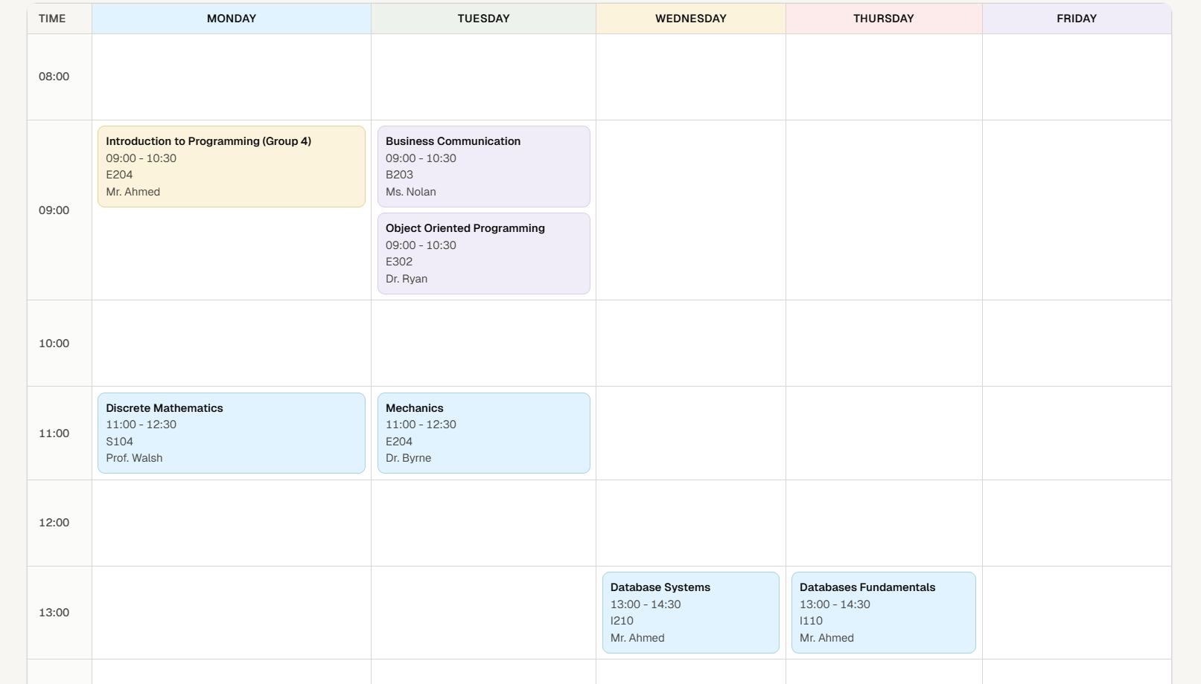
A weekly timetable grid showing classes Monday to Friday with time slots on the left. Each class card displays the module name, time, room, and lecturer. Colour coding is used to distinguish different class types.
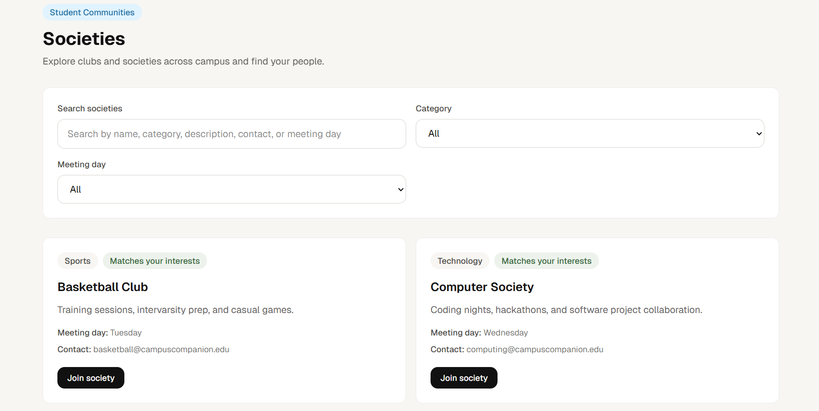
A browsable list of campus clubs and societies with a search bar, category filter, and meeting day filter. Each card shows the society name, description, meeting day, contact email, and a Join society button.

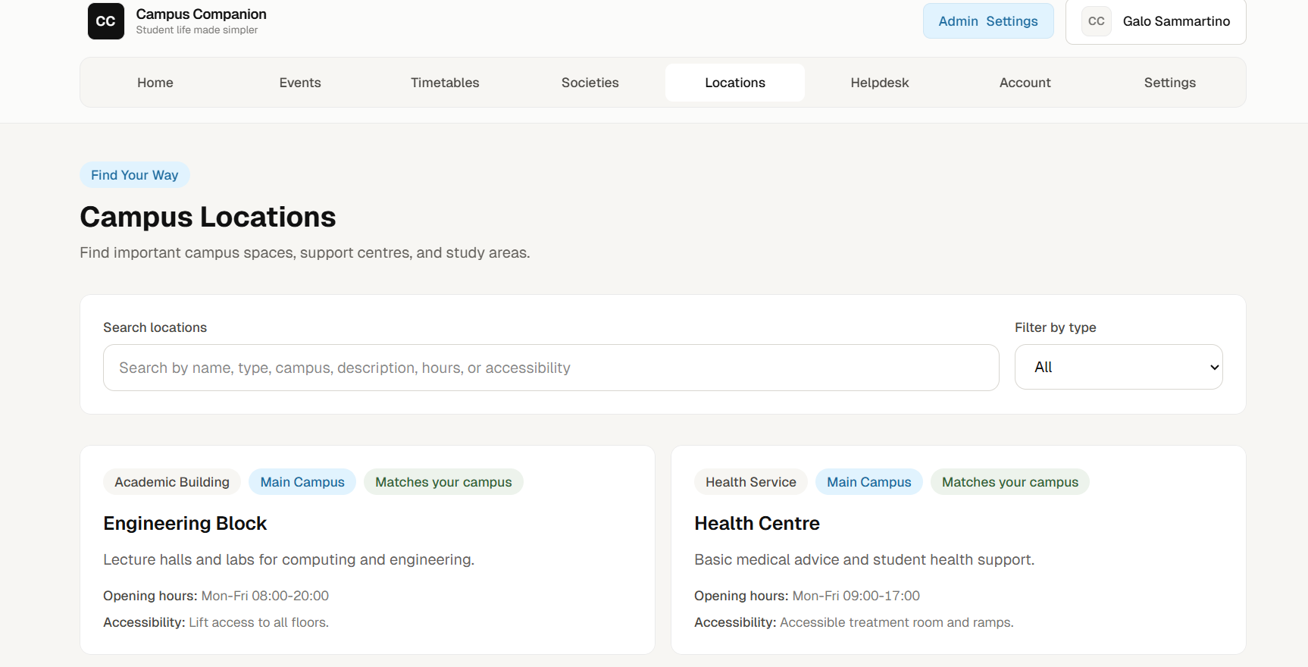
A directory of campus buildings and services with a search bar and a filter by type dropdown. Each location card shows the building name, a short description, opening hours, and accessibility notes.
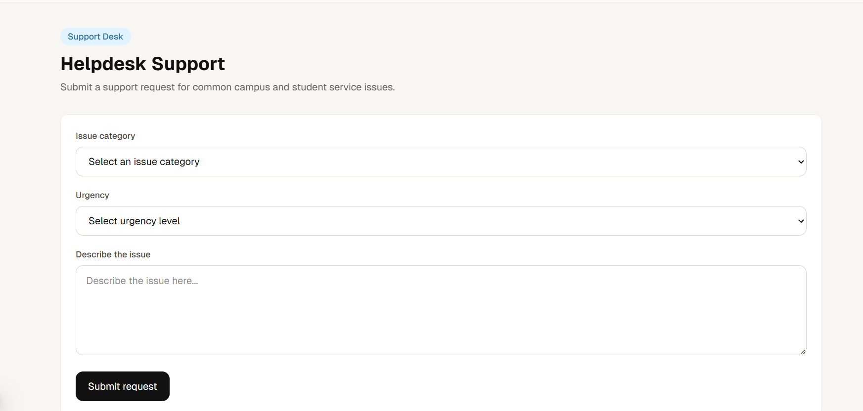

A simple support request form with three fields: issue category, urgency level, and a description text area. A "Submit request" button sits below.
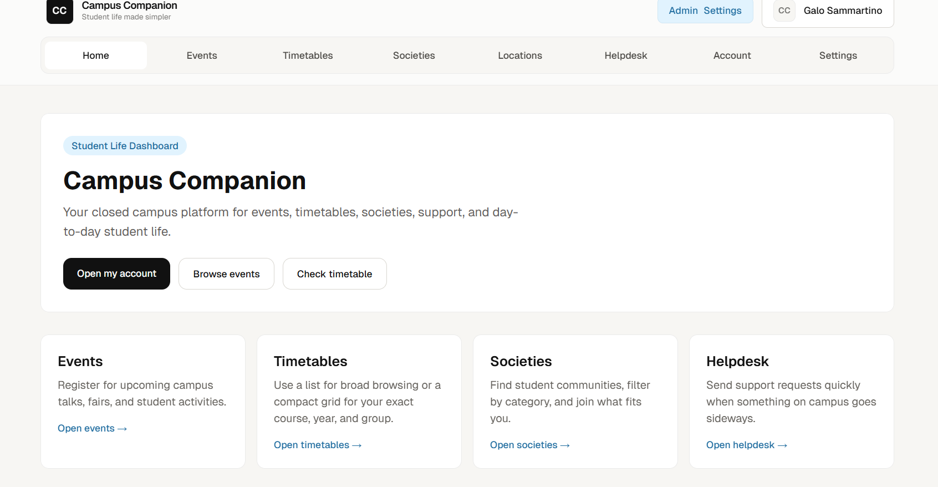The home page displays a clean dashboard layout with a persistent top navigation bar containing links to Home, Events, Timetables, Societies, Locations, Helpdesk, Account, and Settings. The top-right shows the logged-in user with the initials avatar, confirming the authentication system is working. Three call-to-action buttons are presented prominently: Open my account, Browse events, and Check timetable. Below, four quick-link cards: Events, Timetables, Societies, and.

